EXP NO: 09 DATE:

DEVELOP THE BACK-END OF A COMPILER THAT TAKES THREE-ADDRESS

CODE (TAC) AS INPUT AND GENERATES CORRESPONDING 8086 ASSEMBLY LANGUAGE CODE AS OUTPUT.

AIM:

To design and implement the back-end of a compiler that takes three-address code (TAC) as input and produces 8086 assembly language code as output. The three-address code is an intermediate representation used by compilers to break down expressions and operations, while the 8086 assembly code is a machine-level representation of the program that can be executed by a processor.

ALGORITHM:

1. Parse the Three-Address Code (TAC):

Input: Three-Address Code, which is an intermediate representation. For example:

t0 = b + c t1 = t0 * d a = t1

Output: 8086 assembly language code. For example:

MOV AX, [b] ; Load b into AX

ADD AX, [c] ; Add c to AX

MOV [t0], AX ; Store result in t0



1. Process Each TAC Instruction:

1. Initialize Registers:

* + - Set up the registers in 8086 assembly (e.g., AX, BX, CX, etc.) for storing intermediate results and final outputs. o Maintain a temporary register counter for naming temporary variables in TAC

(e.g., t0, t1).

2. For each TAC instruction, based on its operation:

* + - Identify the components: operands and operator. o Choose an appropriate register (AX, BX, etc.) for storing intermediate results. o If the operation involves multiple operands or temporary variables, map them to registers.



1. Translating TAC to 8086 Assembly:

* + Addition/Subtraction (e.g., t0 = b + c):
    - Load operands into registers and perform the operation:

MOV AX, [b] ; Load b into AX

ADD AX, [c] ; Add c to AX

MOV [t0], AX ; Store result in t0

* + Multiplication (e.g., t1 = t0 * d):
    - Load operands into registers and perform the operation:

MOV AX, [t0] ; Load t0 into AX

MOV BX, [d] ; Load d into BX

MUL BX ; Multiply AX by BX (result in AX) MOV [t1], AX ; Store result in t1

* + Assignment (e.g., a = t1):
    - Move the value from a temporary variable to the target variable:

MOV [a], [t1] ; Move value of t1 into a

* + Division (e.g., t2 = b / c):
    - Division is a bit more complex due to the 8086's limitations with the DIV instruction. For example, the result might need to be stored in AX or DX:AX (if it's a 32-bit result):

MOV AX, [b] ; Load b into AX

MOV DX, 0 ; Clear DX (important for division)

MOV BX, [c] ; Load c into BX

DIV BX ; AX = AX / BX (quotient in AX, remainder in DX) MOV [t2], AX ; Store quotient in t2

1. Manage Memory and Registers:

* + Variables: Variables like a, b, c are stored in memory, so you will use memory addressing modes such as [variable_name] to access them.
  + Temporary Variables: Temporary variables like t0, t1, t2, etc., are stored in registers (AX, BX, etc.) or memory if there are more variables than registers available.



1. Handle Control Flow (Optional):

If the TAC contains control structures (such as loops, if-else statements, or function calls), you will need to generate labels and jump instructions in 8086 assembly.

* + If Statements: For example, if (x > 0) { y = 1; } could generate:

MOV AX, [x]

CMP AX, 0

JG positive_case ; Jump if greater

JMP end_if

PROGRAM:

#include <stdio.h>

#include <string.h>

#define MAX_LINES 100

#define MAX_LEN 100

int main() {

char tac[MAX_LINES][MAX_LEN];

int count = 0;

printf("Enter TAC instructions (Ctrl+Z to stop):\n");

// Read all input first

while (fgets(tac[count], sizeof(tac[count]), stdin)) { tac[count][strcspn(tac[count], "\n")] = '\0'; // Remove newline count++;

}

printf("\n--- 8086 Assembly Output ---\n");

// Process each line after input is complete for (int i = 0; i < count; i++) { char lhs[20], op1[20], op2[20], op; if (sscanf(tac[i], "%s = %s %c %s", lhs, op1, &op, op2) == 4) { if (op == '+') {

printf("MOV AX, [%s]\n", op1); printf("ADD AX, [%s]\n", op2); printf("MOV [%s], AX\n\n", lhs);

} else if (op == '-') { printf("MOV AX, [%s]\n", op1); printf("SUB AX, [%s]\n", op2); printf("MOV [%s], AX\n\n", lhs);

} else if (op == '*') { printf("MOV AX, [%s]\n", op1); printf("MOV BX, [%s]\n", op2); printf("MUL BX\n"); printf("MOV [%s], AX\n\n", lhs);

} else if (op == '/') { printf("MOV AX, [%s]\n", op1); printf("MOV DX, 0\n"); printf("MOV BX, [%s]\n", op2); printf("DIV BX\n"); printf("MOV [%s], AX\n\n", lhs);

}

} else if (sscanf(tac[i], "%s = %s", lhs, op1) == 2) { printf("MOV AX, [%s]\n", op1);

printf("MOV [%s], AX\n\n", lhs);

} else {

printf("; Unsupported TAC format: %s\n\n", tac[i]);

}

}

return 0;

}

OUTPUT :

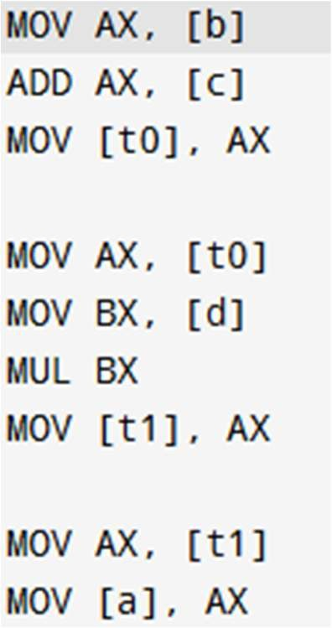

|  |  |
| --- | --- |
| Implementation |  |
| Output/Signature |  |

RESULT:

Thus the above example provides a foundational approach to converting TAC to 8086 assembly using C. For a complete compiler back-end, you would need to handle additional aspects such as register allocation, memory management, and more complex control flow constructs.